# Please find the application screenshots below:

## Search Product:

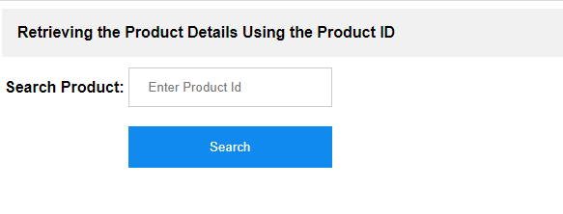

## Product available:

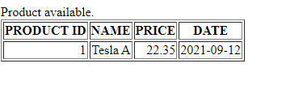

## Product not available:

